10.1. The Main University News System
  - The Main University News System is similar to Departmental News pages but not exactly the same due to specific requirements from the Communications & Public Affairs Department.
University News: http://www.aber.ac.uk/en/news
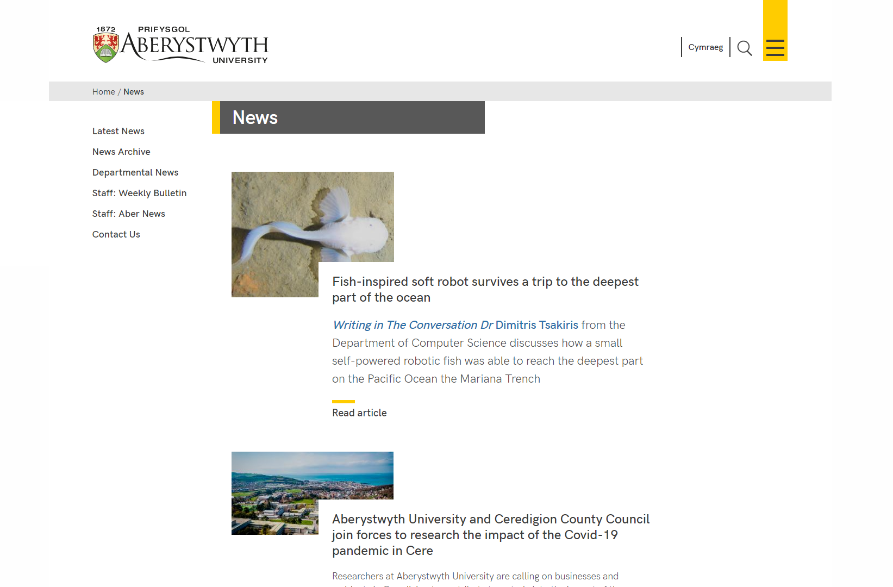
In Departmental News pages, the news items are displayed in certain areas automatically – they appear on the department’s special menu page, and on their news page. The main University News page is different as news items are manually placed into areas on the News page so that staff have complete control. They also appear on the University Home Page.

Creating a News Article
All news articles are created and stored in the News Archive area. This is organized by year and month.
Note that if you are creating a news item at the beginning of a month you may need to create a new section for that month (See Part 4).
- To create a new News Article, open the appropriate month’s section by clicking on it
- Click on the Content tab and you will see any existing news items listed

- Click on the Add content button and choose the ‘News version 2’ template. The template will appear:
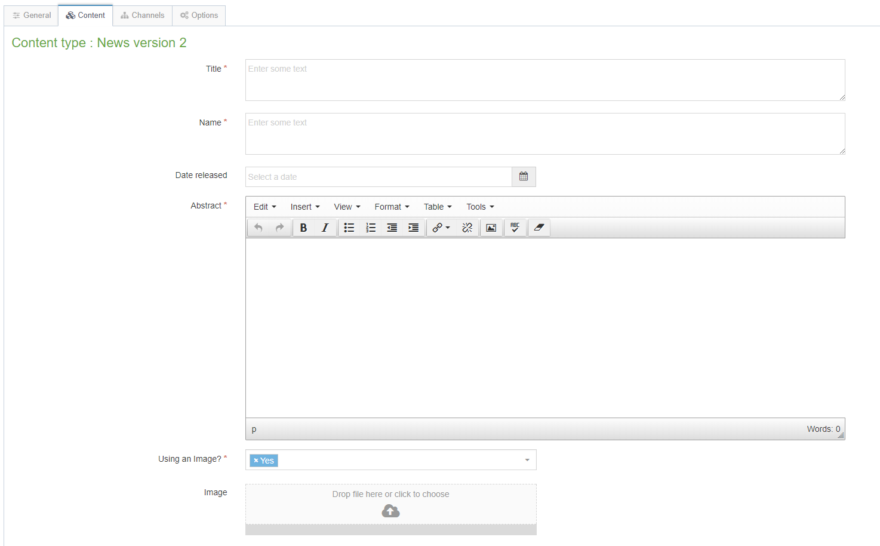
- Fill in as many fields as you have information for – some are essential, and others are optional:
  - Title (essential) – this is the main headline of the news item. Keep this to below 32 characters.
  - Name (essential) – this is the name of the piece of content and doesn’t show up for people viewing the web page – it’s just for you and your colleagues to know what this piece of content is.
  - Date released (essential) – this is NOT filled in for you automatically with the current date and time. To add the current date and time, just click into the box so that it puts this in. Alternatively choose the date and time of your choice after clicking in the box. Changing this date will not affect when the news article shows up on the web site – this is done by another mechanism – see point 6 for more information.
  - Abstract (essential) – this is a brief summary of what the news article contains – it will appear on the News page (only for stories in the central area of the page).
  - Using an image? (essential) – choose whether or not the news article will have an image
  - Image – choose an image to upload to go with the news article, if you are using one – this should be up to 1140x500px
  - Image Size – choose the correct option based on the size of your image (see above)
  - Caption – this is the caption to go with the image – it will become the alternative text for the image and will also show beneath the image when the full article is viewed. If you are using an image you need to fill in the caption.
  - Full text (essential) – this is the main text of the news article.
  - YouTube Video Code – if you need to display a video with your news article, enter the code here. You just need the last part of the YouTube address.
  - Full text part 2 – this allows you to continue the text of the article after the YouTube video if necessary
  - Links – this is where you can place any links related to the article – these will be placed in the bottom part of the right-hand column. You should use a bulleted list for the links, and they should be text links – i.e. don’t just type in the web address of a web site.
  - Contacts – this is a list of any contacts for this news – the contacts appear in the right-hand column when the article is viewed.
  - News code (essential) – this is where you type the code for the news item.
  - Add to AU Homepage? – this should be ticked if the article should be displayed on the university homepage. If you leave it unticked the story will only be available from the news page
- Click on the Save changes button to finish. You will be returned to the list of content.
- If you now preview the appropriate month in the CMS, you should see your new News Article appearing in the list.

Placing the News Item on the News Page
So far, your news item is only appearing in the news archive, not on the main news page. To place the item, you will need to mirror it to the appropriate section.
- If you want your news item to appear at the top, you will need to mirror it into the section called “main story”.
- If you want your news item to appear underneath, mirror it to “top story”.
When you add new stories to parts of the News Page, remember that you will need to reorganize other stories. If you add a new story to “main story” you will need to move the old story down into “top story”. Then you may also need to move stories out of “top story” if the page is getting too long.
- To move an item from the main story to top story, open the main story section, find the content you want to move and choose ‘move’ from the Actions menu for that piece of content. You’ll then need to choose top story as the new location for it.
- To remove a story from top story, simply go to the piece of content and choose ‘delete’ from the Actions menu for that piece of content. You will be asked if you want to remove it from the section or completely delete it – keep the option set to just remove from this section and click on Confirm. The story will still be available from the News Archive but will no longer show on the main news page.

Adding New Months to the Archive
(Using the year 2018 as an example)
- Step 1
  - On the CMS site structure, expand News, News Archive & 2018 (Newyddion, Archif Newyddion, 2018). Use the Actions menu to the right of 2018 and select Create Section.
  - Name the section with the month name, and put the number of the month (with an 0, e.g. March is 03) in the Output URI box.
  - Click Save changes to finish.
  - Switch language, find the section you just created & click on it, then name the section in the other language and put the same number in the Output URI.
  - Click Save changes to finish.
  - Switch back to your preferred language.
- Step 2
  - On the CMS site structure, click on the section called “2018”, open the content tab, and modify the content called “2018”.
  - Add another bullet point by putting your mouse at the end of the last month and hitting enter.
  - Write the name of the month, select it, click the “Insert Link” button and choose 'Insert section link'. In the Select section window, find the new month section you created in step 1 and click on it to select it.
  - Click Save changes to save this piece of content.
  - Switch language and do the same thing again in the other language.
  - Switch back to your preferred language.
- Step 3
  - On the CMS site structure, click on the section called “News Archive” or “Archif Newyddion”, open the content tab, and modify the content called “2018”.
  - Add another bullet point by putting your mouse at the end of the last month and hitting enter.
  - Write the name of the month, select it, click the “Insert Link” button and choose 'Insert section link'. In the Select section window, find the new month section you created in step 1 and click on it to select it.
  - Click Save changes to save this piece of content.
  - Switch language and do the same thing again in the other language.
  - Switch back to your preferred language.

Adding a New Year to the Archive
(Using the year 2019 as an example)
- Step 1
  - On the CMS site structure, expand News & News Archive (Newyddion, Archif Newyddion). Use the Actions menu to the right of News Archive and select Create Section.
  - Name the section with the year (e.g. 2019) and use the same in the Output URI box.
  - Click Save changes to finish.
  - Switch language, find the section you just created & click on it, then name the section with the year again and put the same in the Output URI.
  - Click Save changes to finish.
  - Switch back to your preferred language.
- Step 2
  - On the CMS site structure, use the menu to the right of your new section (e.g. 2019) and select Add Section.
  - Name the section “January”, and put the 01 in the Output URI box.
  - Click Save changes to finish.
  - Switch language, find the section you just created & click on it, then name the section in the other language and put the same number in the Output URI.
  - Click Save changes to finish.
  - Switch back to your preferred language.
- Step 3
  - On the CMS site structure, click on your new year section (eg 2019), open the content tab, click on Add Content, and choose General Content.
  - Name the content with the year, and put the same in the Title box
  - Create a bullet point with the word “January” and select this text, click the “Insert Link” button and choose 'Insert section link'. In the Select section window, find the January section you created in step 2 and click on it to select it.
  - Click Save changes to save this piece of content.
  - Switch language and do the same thing again in the other language.
  - Switch back to your preferred language.
- Step 4
  - On the CMS site structure, click on the section called “News Archive” or “Archif Newyddion”, open the content tab, click on Add Content, and choose Expanding Content.
  - Name the content with the year, and put the same in the Link Text box
  - Create a bullet point with the word “January” and select this text, click the “Insert Link” button and choose 'Insert section link'. In the Select section window, find the January section you created in step 2 and click on it to select it.
  - Tick the Last List Item tick box near the bottom of the piece of content
  - Click Save changes to save this piece of content.
  - Switch language and do the same thing again in the other language.
  - Switch back to your preferred language.
- Step 5
  - On the CMS site structure, click on the section called “News Archive” or “Archif Newyddion”, open the content tab, click on the piece of content from the previous year (eg 2018).
  - Scroll down and tick the List Item box and untick the Last List Item box.
  - Click Save changes to save this piece of content.
  - Switch language and do the same thing again in the other language.
  - Switch back to your preferred language.

